

**CY-3001 : Networks and Cyber Security II**

Semester Project

**“ INCIDENT RESPONSE”**

**Project Report**

*Submitted by:*

Laila Tariq, Bakhtawar Ilyas, Yumna Shahzad

22i-1574, 22i-1665, 22i-1571

CY-B

*Submitted to:*

Sir Abdullah Abid

Department of Cybersecurity BS(CYS)

FAST-NUCES Islamabad

                                                Submission Date: 12/4/2024

**Table of Contents**

· **Introduction** ............................................................... 3

· · **Overview of Tools Used** .............................................. 3  
2.1 **Wazuh** ................................................................... 3  
2.2 **ModSecurity** ........................................................... 3  
2.3 **Snort** ................................................................... 4  
2.4 **Hydra** ................................................................... 4  
2.5 **MXToolBox** ............................................................ 4  
2.6 **Fail2Ban** ............................................................... 4

· · **Incidents** .................................................................. 5  
3.1 **Incident 1 (Part A): Wazuh and SQL Injection** ................ 5  
3.1.1 **Wazuh Installation and Configuration** ...................... 5  
3.1.2 **First Approach: SQL Injection Setup Using DVWA** ....... 7  
3.1.3 **Second Approach to Manage Wazuh** ....................... 12  
- **Overview** ........................................................... 12  
- **Steps to Set Up** ................................................. 12  
- **Dashboard Features and Testing** ...................... 13  
- **Outcome** ........................................................... 13  
- **Configuring Wazuh on Kali Linux** ....................... 13  
3.1.4 **SQL Injection Attack Execution** ....................... 17

3.2 **Incident 1 (Part B): ModSecurity and SQL Injection** ...... 21  
3.2.1 **SQL Injection Attacks** .................................. 21  
3.2.2 **Web Application Firewall (ModSecurity)** ......... 21

3.3 **Incident 2: Snort and Hydra (Brute-Force Attack)** ....... 28  
3.3.1 **Brute-Force Attacks Overview** .......................... 28  
3.3.2 **Intrusion Detection System (Snort)** ................... 28

3.4 **Incident 3: MXToolBox and Fake Email (Email Spoofing)** .. 33  
3.4.1 **Email Spoofing Overview** ................................. 33

3.5 **Incident 4: Fail2Ban and SSH Intrusion Prevention** ......... 35  
3.5.1 **SSH Intrusion Attempts** ................................. 35  
3.5.2 **Fail2Ban and Log Analysis** ............................. 37

3.6 **Incident 5 (Bonus): Medusa Brute-Force Attack** ............ 40

**Challenges and Learnings** .......................................41 **Conclusion** ........................................................... 41 **References** ........................................................... 42

# **Introduction :**

In today's digital age, cyberattacks are a constant threat to organizations and individuals. Incident response, a critical aspect of cybersecurity, involves systematically managing and mitigating these threats. This project explores incident response through practical implementations, simulating real-world attack and defense scenarios using tools such as ModSecurity, Snort, Hydra, MXToolBox, and Fail2Ban.

The focus is to analyze the effectiveness of these tools in detecting, preventing, and mitigating cyberattacks, emphasizing an integrated approach to cybersecurity. The project covers four key incidents: SQL injection attacks, brute-force attempts, email spoofing, and SSH intrusion attacks. Each incident includes detailed configurations, methodologies, and results to demonstrate the tools' capabilities.

Through this work, we highlight the importance of proactive defense mechanisms and offer insights into best practices for enhancing cybersecurity resilience.

# **2) Overview of Tools Used:**

### **2.1 :Wazuh:**

          Wazuh is an open-source security platform designed to help organizations detect and respond to security threats, monitor system activities, and comply with regulatory requirements. It provides a comprehensive solution for endpoint detection and response (EDR), log management, and security information and event management (SIEM).

### **2.2 ModSecurity:**

  ModSecurity is an open-source web application firewall (WAF) that acts as a security layer for web servers, detecting and blocking a wide range of threats such as SQL injection, cross-site scripting (XSS), and other web application attacks. It functions by analyzing incoming HTTP requests and responses, applying a set of security rules to identify and mitigate potential threats. ModSecurity can be integrated with Apache, Nginx, and IIS servers, providing an additional layer of defense against malicious activity.

### **2.3 Snort :**

Snort is an open-source network intrusion detection and prevention system (IDS/IPS) that analyzes network traffic in real-time to detect malicious activity. It uses a combination of signature-based detection, protocol analysis, and anomaly detection to identify and block threats like SQL injection, buffer overflows, and malware. Snort is highly configurable and can be used to monitor network traffic, log suspicious activities, and generate alerts when potential threats are detected.

### **2.4 Hydra :**

Hydra is a popular password-cracking tool used to perform brute-force attacks on various network services, including SSH, HTTP, FTP, and others. It works by attempting different combinations of usernames and passwords from a provided list until it successfully authenticates. Hydra is commonly used in penetration testing to assess the strength of password security, but it can also be used by attackers to gain unauthorized access to systems with weak password policies.

### **2.5 MXToolBox:**

MXToolBox is an online diagnostic tool that provides a suite of services for checking and troubleshooting various aspects of domain and email infrastructure. It is commonly used to check domain DNS records, mail server configurations, blacklist status, and overall email deliverability. By performing various tests, MXToolBox helps users identify issues like misconfigured email servers or blacklisting that could affect email communication and security.

### **2.6 Fail2Ban:**

Fail2Ban is a security tool that monitors log files for suspicious activity and automatically blocks IP addresses that exhibit malicious behavior, such as repeated failed login attempts. It works by configuring firewall rules to block offending IPs for a specified duration, reducing the risk of brute-force attacks. Fail2Ban can be customized to protect various services, including SSH, HTTP, and more, making it a vital component in protecting servers from automated attacks.

# **3) Incidents**

## **3.1  Incident 1 (Part a): Wazuh and SQL Injection:**

### **3.1.1 Wazuh Installation and Configuration:**

**WAZUH:** Wazuh, an open-source security platform, was managed through two primary methods during our setup and usage. The first approach involved direct interaction via the terminal. This method encompassed executing commands to install, configure, and manage Wazuh components on the system. Key terminal-based tasks included adding repositories, downloading necessary packages, and configuring files to enable communication between the Wazuh manager and agents. Using the command line allowed for precise control over configurations, ensuring that the Wazuh service was tailored to meet specific security and monitoring requirements. Additionally, the terminal provided real-time feedback on the system's status, enabling quick troubleshooting and verification of successful deployments. This hands-on method highlighted the robustness of terminal-based administration in cybersecurity workflows.

### **3.1.2: First Way**

**Installation and Configuration:**

To install the Wazuh agent and manager, the process began with updating the system using sudo apt update && sudo apt upgrade -y to ensure all packages were current. For the Wazuh Manager, the Wazuh repository was added to the system, followed by the installation of required dependencies and the manager itself using apt install wazuh-manager. After installation, the manager’s configuration file was edited to set up communication parameters. Similarly, for the Wazuh agent, the repository was added, and the agent was installed using apt install wazuh-agent. The agent's configuration file was modified to specify the manager’s IP address, ensuring proper communication. Finally, the services for both the manager and agent were started and enabled using systemctl start and systemctl enable commands, completing the setup.

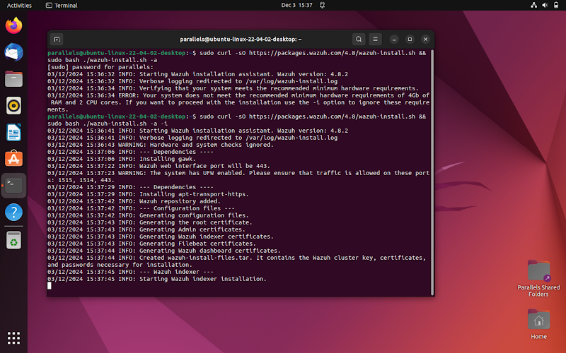

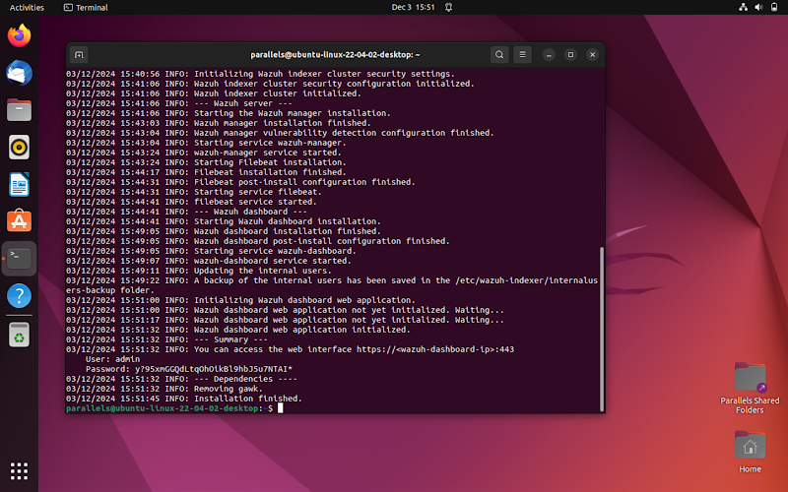

Wazuh Manager successfully configured.

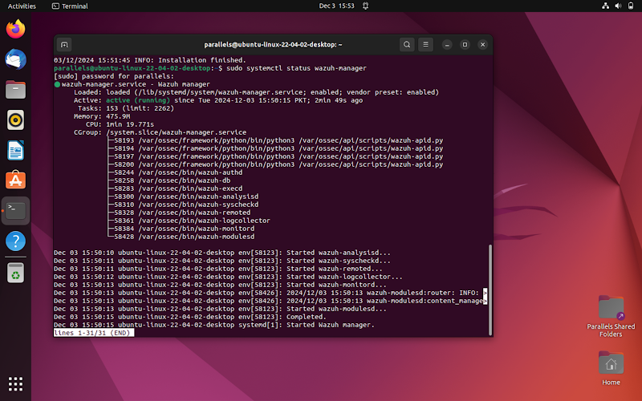

Wazuh agent successfully configured.

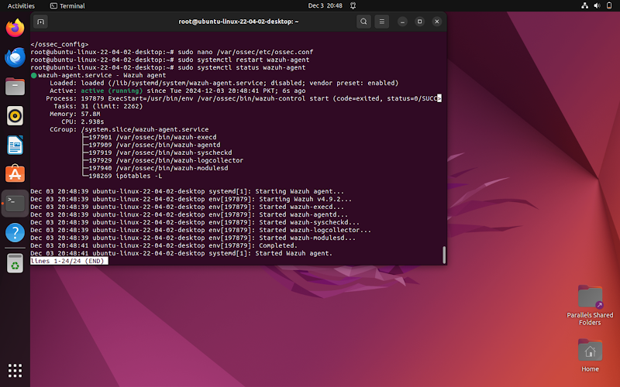

### **SQL Injection Setup Using DVWA**

**Install and Configure DVWA**:

* Install DVWA on a local or virtual server environment.
* Set up a LAMP stack (Linux, Apache, MySQL, PHP).

**Define Database Credentials**:

* Access the config.inc.php file.
* Configure it with database credentials to enable communication with MySQL.

**Initialize the Database**:

* Use the DVWA interface to click "Create/Reset Database" on the setup page.

**Enable SQL Injection Testing**:

* Log in to DVWA and set the security level to "Low" for intentional vulnerabilities.
* This step relaxes input validation and database query security.

**Conduct SQL Injection Testing**:

* Navigate to the SQL Injection section of DVWA.
* Test SQL injection techniques, such as appending malicious queries to inputs.
* Observe application behavior to understand the risks of poor input sanitization.

.

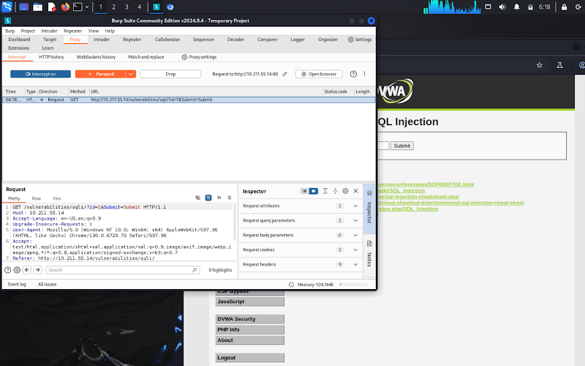

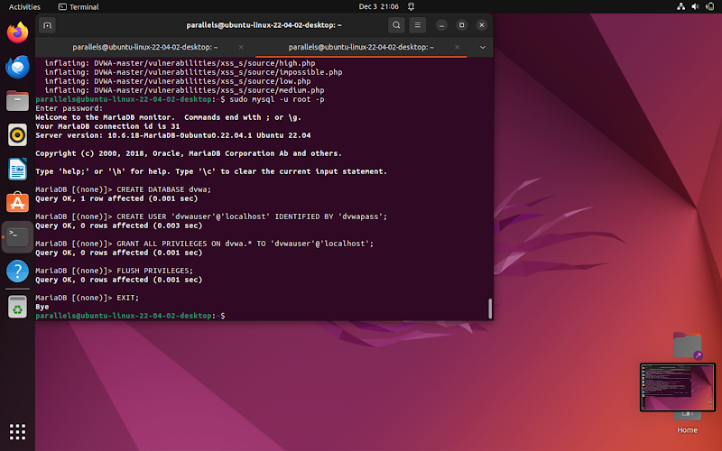

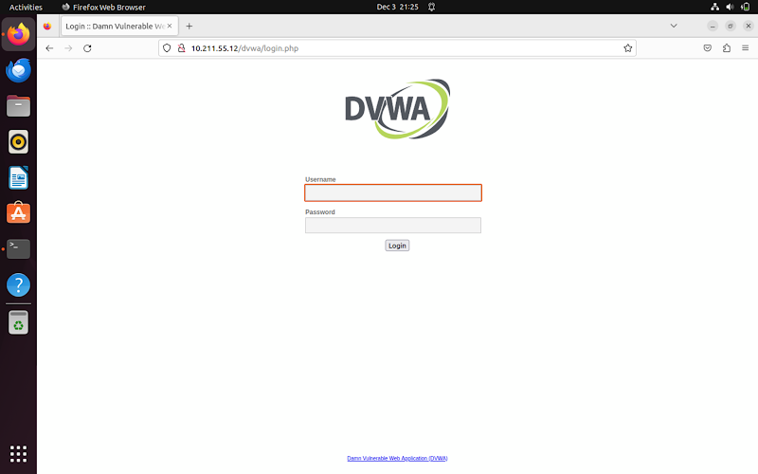

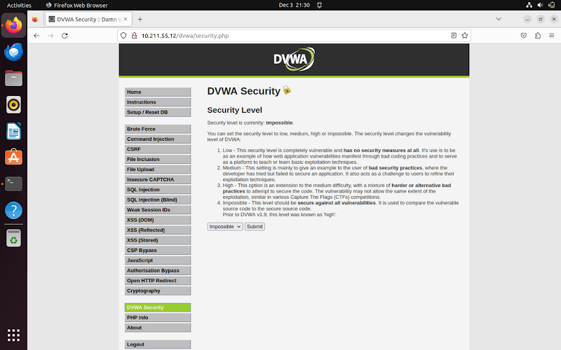

1. **Successful sql injection attack**

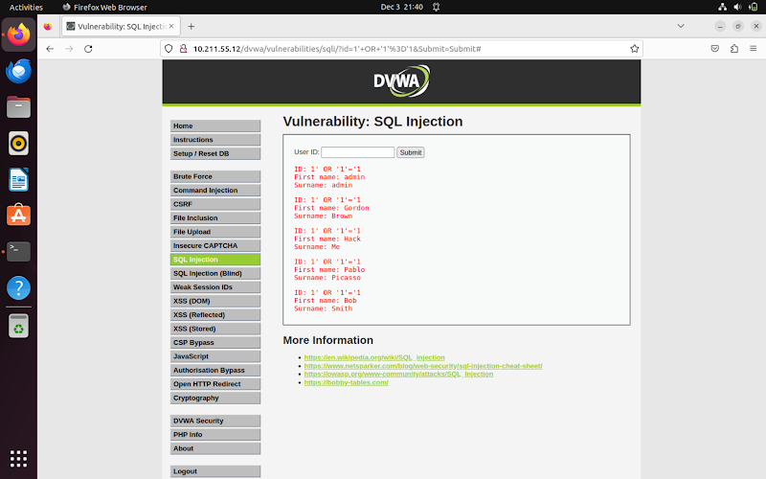

1. **After enabling another attack done.**

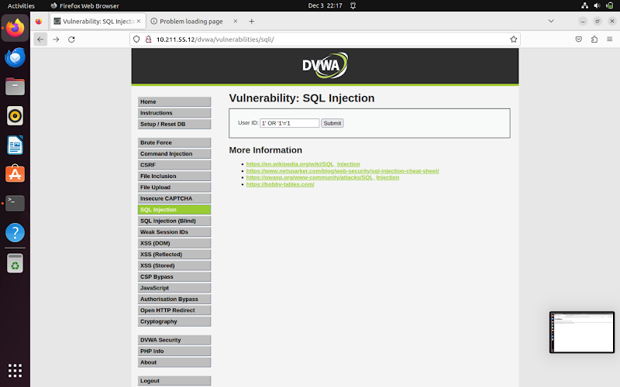

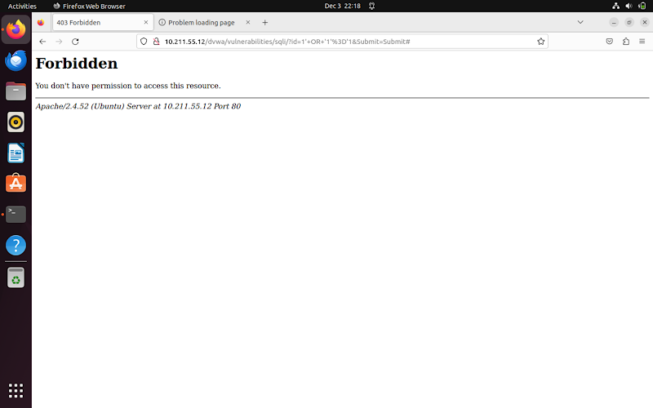

### **3.1.3: Second Way to Manage Wazuh**

#### **Overview**

Utilized the Wazuh dashboard for management.

**Setup**:

* **Kali Docker**: Acts as both the Wazuh Manager and the attacker.
* **Ubuntu**: Serves as the Wazuh Agent.

#### **Steps to Set Up**

**Deploy Wazuh Manager on Kali (Docker):**

* Pull the official Wazuh Docker image.
* Start the container with proper network configurations.
* Access the dashboard via the Wazuh Manager’s IP address and port through a web browser.

**Configure Wazuh Agent on Ubuntu:**

* Install the Wazuh Agent on the Ubuntu machine.
* Modify the agent’s configuration file to point to the Wazuh Manager’s IP address.
* Register the agent with the Manager using the authentication key from the dashboard.

#### **Dashboard Features and Testing**

**Centralized Interface**:

* View alerts and logs.
* Monitor the environment in real time.

**Simulated Security Events**:

* Use Kali Linux to execute simulated attacks (e.g., port scans, brute-force attempts).
* Test the Wazuh Agent’s detection capabilities through the dashboard.

#### **Outcome**

* Demonstrated Wazuh’s practical application in identifying and responding to security threats within a dynamic testing environment.

### **Configuring Wazuh on Kali Linux**

**Set Up Docker**:

* Install Docker using commands like sudo apt update and sudo apt install docker.io.
* Ensure the Docker service is running.

**Deploy Wazuh Manager and Dashboard**:

* Pull the Wazuh Docker image: docker pull wazuh/wazuh.
* Use a Docker Compose file to configure and start the Wazuh Manager, dashboard, and necessary network settings (docker-compose up -d).
* Access the dashboard via a web browser at https://10.211.55.14:443.

**Generate Agent Registration Key**:

* Create and save the key from the dashboard to authenticate the Wazuh Agent on Ubuntu.

**Configure Network Communication**:

* Allow traffic on necessary ports (e.g., 1514 for logs and 1515 for API) via the Kali firewall to ensure proper communication with the Wazuh Agent.

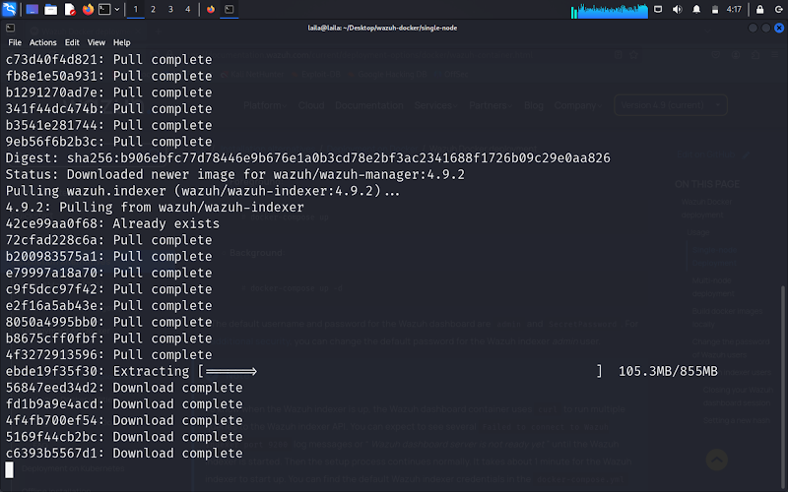

**Enabling agent on Ubuntu**

To enable the Wazuh Agent on Ubuntu through the Wazuh dashboard, I started by accessing the Wazuh Manager's dashboard hosted on Kali via a web browser. After logging in with the administrator credentials, I navigated to the "Agents" section in the dashboard.

Here, I added a new agent entry by selecting the option to register an agent. I specified the agent's name (to represent the Ubuntu machine) and its group. The dashboard generated an authentication key specific to this agent, which I copied for use during the agent configuration on Ubuntu.

On the Ubuntu machine, I opened the Wazuh Agent's configuration file located at /var/ossec/etc/ossec.conf. In this file, I added the Manager's IP address under the <server> section to ensure proper communication. Next, I registered the agent with the Wazuh Manager by running the following command, using the authentication key provided by the dashboard:

sudo /var/ossec/bin/agent-auth -m <manager_ip> -A <agent_name> -k <auth_key>

After successful registration, I started the Wazuh Agent service with:

sudo systemctl start wazuh-agent

I confirmed the agent was active by returning to the Wazuh dashboard and checking the "Agents" list, where the Ubuntu agent appeared as connected and began reporting logs to the Manager.

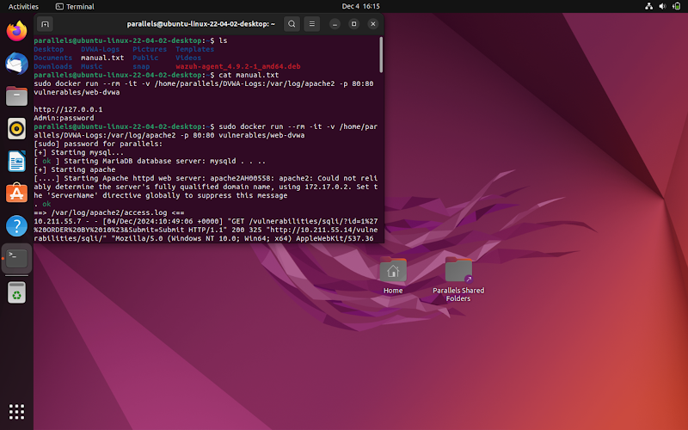

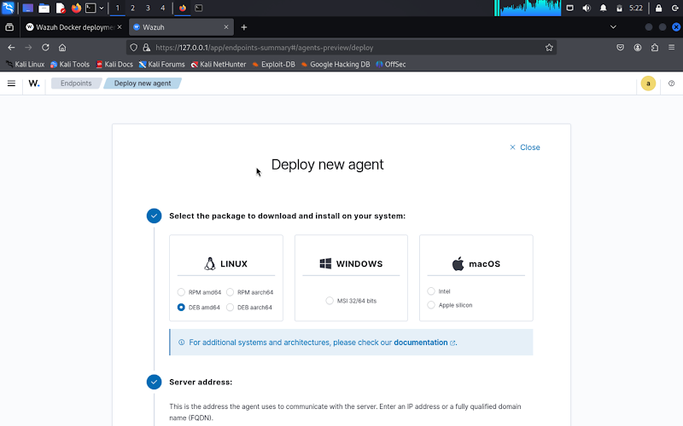

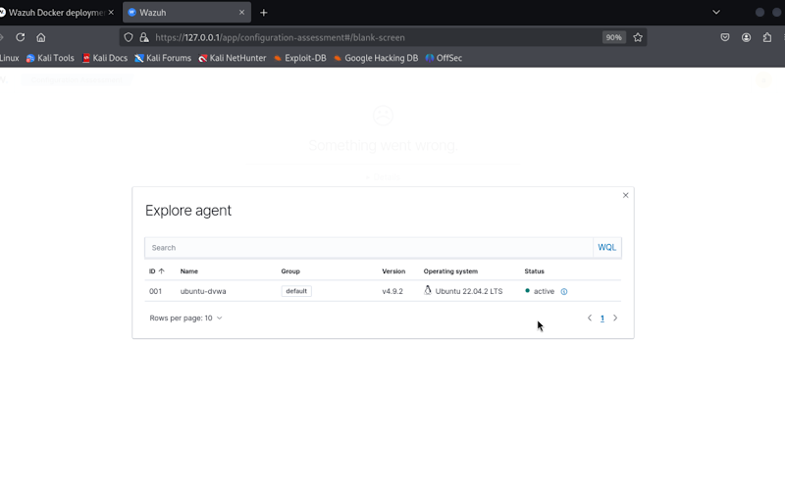

**Wazuh Successfully Configured/Dashboard**

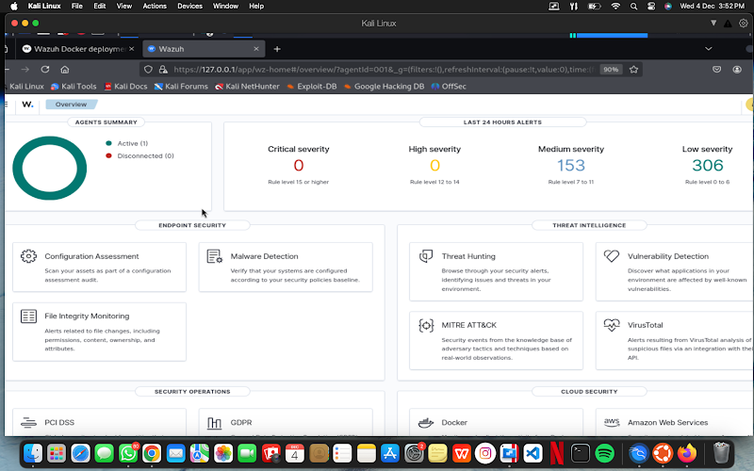

### **3.1.4 :SQL Injection Attack:**

* **Setup and Preparation**:
* Installed DVWA on Ubuntu using a LAMP stack.
* Set DVWA’s security level to "Low" to expose SQL injection vulnerabilities.
* **Performing the Attack**:
* Burp**Suite**: Intercepted and modified HTTP requests to inject malicious SQL queries (e.g., ' OR '1'='1).
* **SQLmap**: Automated SQL injection to exploit DVWA’s vulnerabilities, extracting database details like tables and columns.
* **Monitoring and Detection with Wazuh**:
* Wazuh Agent on Ubuntu monitored server logs (e.g., Apache) for suspicious activity.
* Wazuh Manager on Kali analyzed logs and detected SQL injection attempts using predefined rules.
* Triggered real-time alerts on the dashboard with details like:
* Source IP and targeted endpoints (e.g., DVWA login).
* Specific malicious payloads used.
* Categorized threat severity.
* **Outcome**:
* Reviewed detailed alerts on the Wazuh dashboard, confirming real-time detection of SQL injection attacks.
* Demonstrated Wazuh’s effectiveness in identifying and responding to web application vulnerabilities.

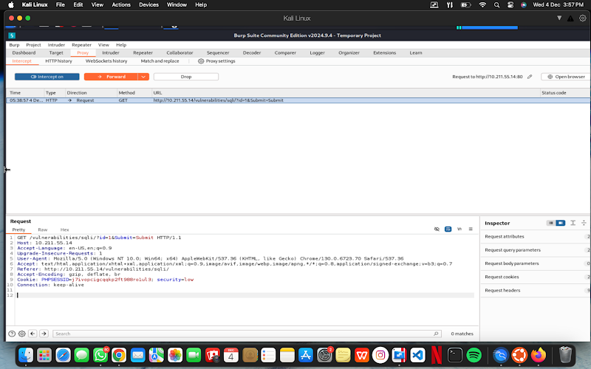

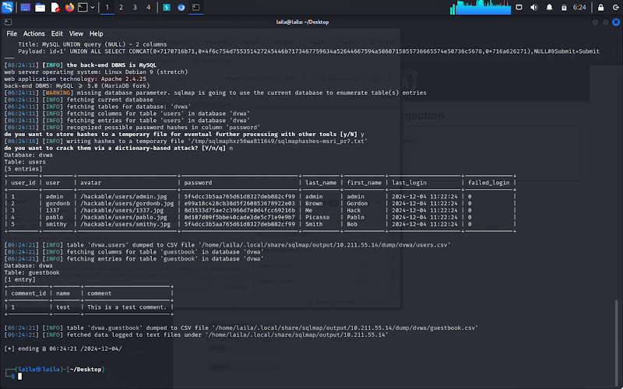

**Result on Wazuh Dashboard**

The Wazuh dashboard displayed the results of the SQL injection performed on DVWA using Burp Suite by actively monitoring and analyzing the logs from the Ubuntu machine hosting DVWA. When I executed SQL injection attacks, such as attempting to bypass authentication with payloads like ' OR '1'='1 through Burp Suite, Wazuh captured the malicious activity in real-time.

The Wazuh Agent on Ubuntu monitored key log files, including web server logs (e.g., Apache or Nginx logs). These logs recorded the suspicious input sent via SQL injection. The agent forwarded these logs to the Wazuh Manager, which correlated the data and applied detection rules.

On the Wazuh dashboard, under the "Security Events" or "Alerts" section, alerts related to SQL injection appeared. These alerts included detailed information such as:

* Timestamp of the attack.
* Source IP address of the attacker (from Burp Suite).
* Target application and endpoint (e.g., the DVWA SQL injection page).
* Payload details, highlighting the injected malicious query.
* Severity level of the alert, categorized based on Wazuh’s rules.

By clicking on the alert, I accessed additional insights, including the detection rule triggered (e.g., "SQL Injection Attempt Detected") and remediation suggestions. This demonstrated Wazuh’s ability to identify web application vulnerabilities and malicious activities in a simulated attack environment.

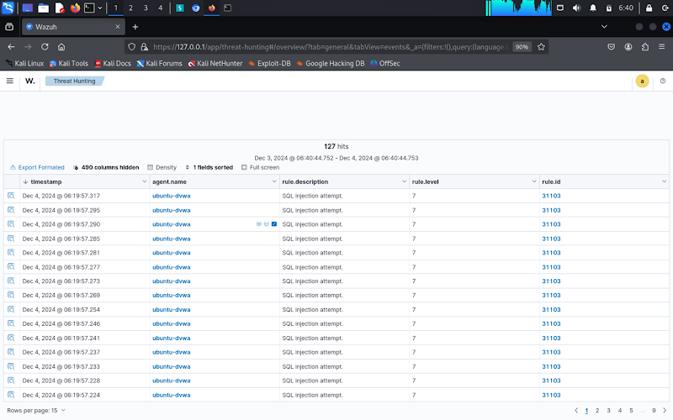

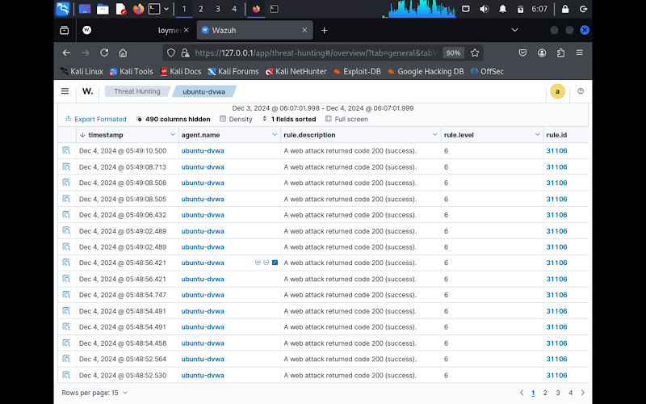

## **3.2 Incident 1 (Part b) : ModSecurity and SQL Injection**

### **3.2.1 SQL Injection Attacks**

SQL Injection is a critical cyberattack where attackers manipulate SQL queries through web application input fields, enabling them to execute arbitrary commands on a database. This attack can lead to unauthorized access, data exfiltration, and even modification or deletion of database content.

Mitigating SQL injection involves:

l Using parameterized queries.

l Validating and sanitizing user inputs.

l Employing security tools like Web Application Firewalls (WAFs) to detect and block malicious inputs.

### **3.2.2 Web Application Firewall (ModSecurity)**

To prevent SQL injection, ModSecurity was installed and configured on an Apache web server as a WAF.Below are the steps and results of the setup:

**1)Installation and Configuration:**

l Installed the **libapache2-mod-security2** package.

l Enabled ModSecurity by setting SecRuleEngine On in the modsecurity.conf file.

l Integrated the **OWASP Core Rule Set (CRS)** to detect common web vulnerabilities, including SQL injection.

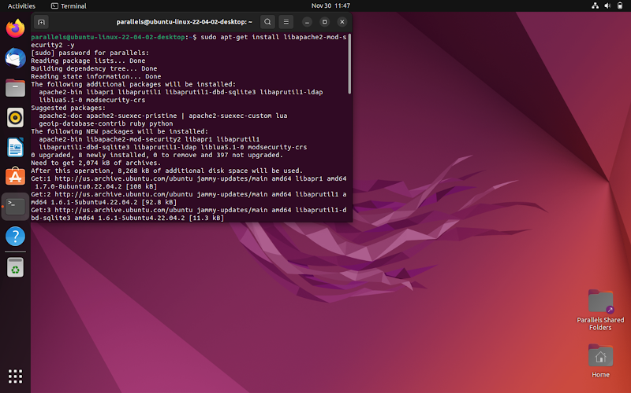

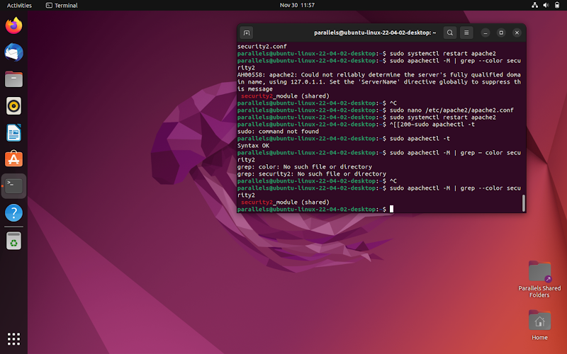

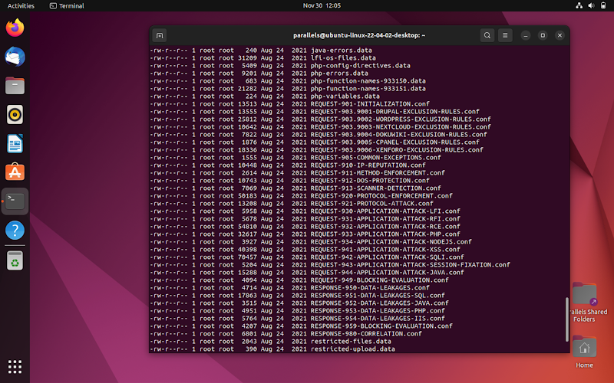

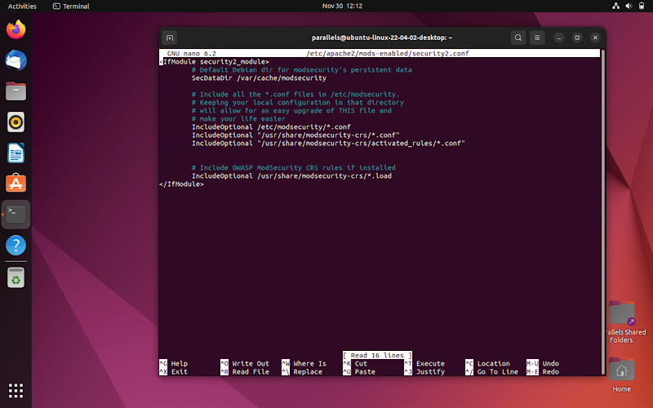

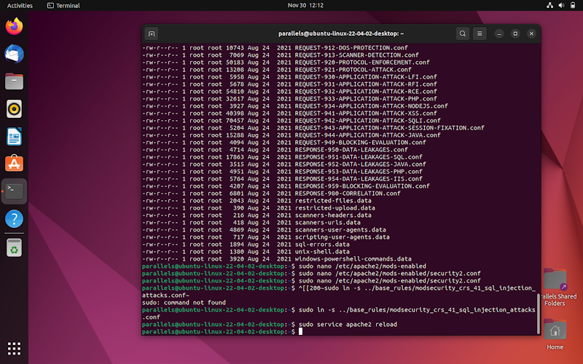

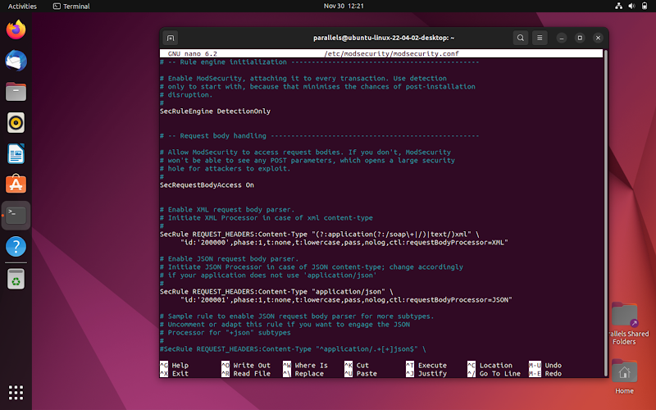

**2)Attack Simulations:**

**l) Manual Injection:**

A vulnerable PHP-based application was created, where the input could be manipulated.

Injected the payload:

**http://localhost/vulnerable/index.php?username=admin' OR '1'='1**

Result: ModSecurity blocked the request and returned a **403 Forbidden** status. Logs captured the payload and identified it as a critical SQL injection attempt, triggering CRS rule ID 981176.

**l) Automated Attack using SQLMap:**

· SQLMap was used to target the same application with various injection techniques (boolean-based, error-based, and time-based).

· Result: ModSecurity effectively blocked the attack, logging the attempts. SQLMap reported the parameter as non-injectable, showcasing ModSecurity's effectiveness.

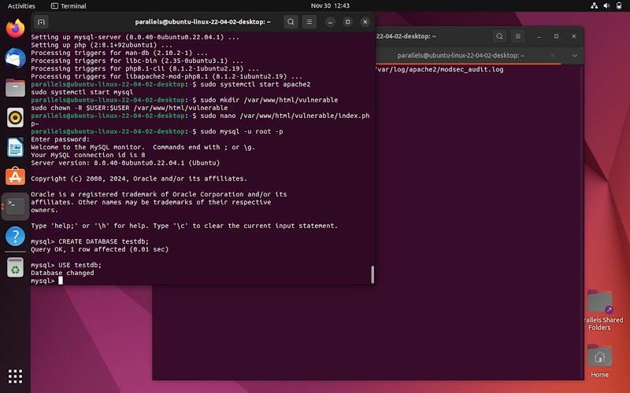

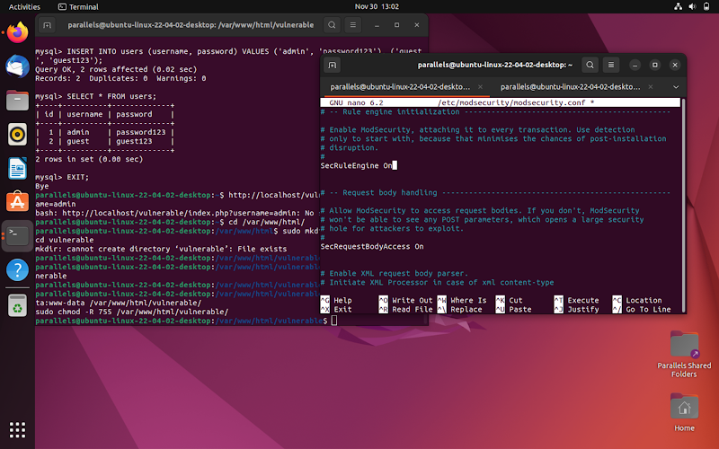



We used sqlmap to perform an SQL injection attack on our own server running a vulnerable PHP application. I directed the attack by specifying the target URL with the vulnerable username parameter in the request. Upon executing the command, sqlmap attempted several types of SQL injection techniques, including boolean-based, error-based, and time-based injections. However, the attack was unsuccessful, as the server responded with a 403 Forbidden error, likely due to a web application firewall (WAF) or ModSecurity blocking the requests. Additionally, sqlmap indicated that the parameter did not appear to be injectable, and suggested increasing the risk and level for more aggressive tests or using tamper scripts to bypass protections. The output also indicated that our version of sqlmap was outdated, so updating the tool might improve the attack's success.

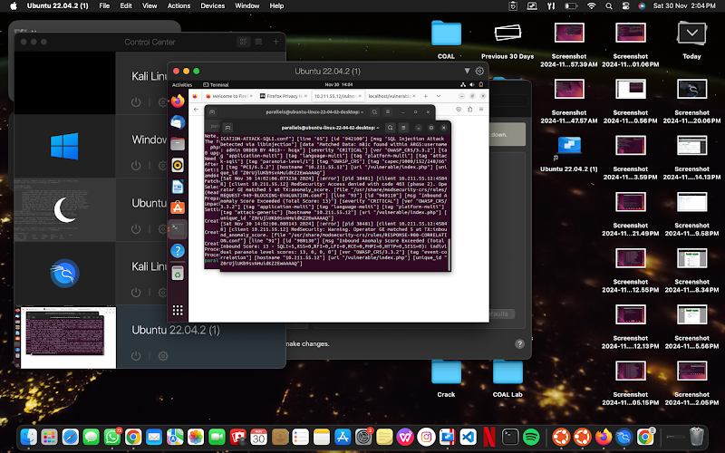

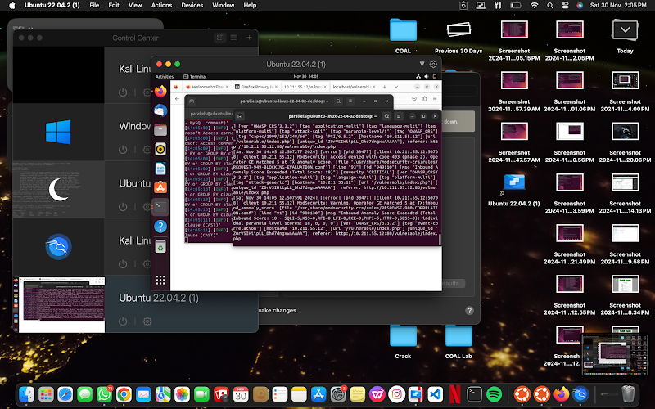

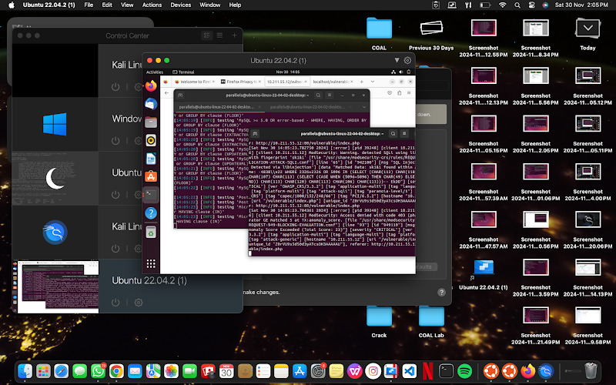



## **3.3:Incidence 2: Snort and Hydra**

### **3.3.1 Brute-Force Attacks**

Brute-force attacks involve systematically trying combinations of usernames and passwords to gain unauthorized access to a system. These attacks exploit weak or predictable credentials and are a common vector for compromising network services such as FTP, SSH, and HTTP.

To simulate a brute-force attack, Hydra was used to target the server’s FTP service. It attempted multiple login combinations using a predefined password list. During the simulation:

· Hydra demonstrated the potential vulnerabilities of weak credentials.

· Observations showed that after three failed attempts, the system logged out, requiring a restart of the process, indicating some inherent protections against repeated failures.

### **3.3.2 Intrusion Detection System (Snort)**

Snort was installed and configured as an Intrusion Detection System (IDS) on an Ubuntu server to monitor and protect against potential brute-force attacks.

**Configuration and Setup:**

To begin, I installed and configured Snort on the Ubuntu server to provide an additional layer of security against potential attacks, including brute-force attempts. First, I used the package manager to install Snort with the command sudo apt install snort. After installation, I configured Snort to monitor and detect malicious activities by editing its configuration file (/etc/snort/snort.conf) and customizing the network interface to be monitored. I then ensured that Snort was set up to log intrusion attempts and configured it to run in "alert" mode, where it would notify administrators of suspicious activities, such as brute-force attacks. Once Snort was properly configured and running, I started the service using sudo systemctl start snort.

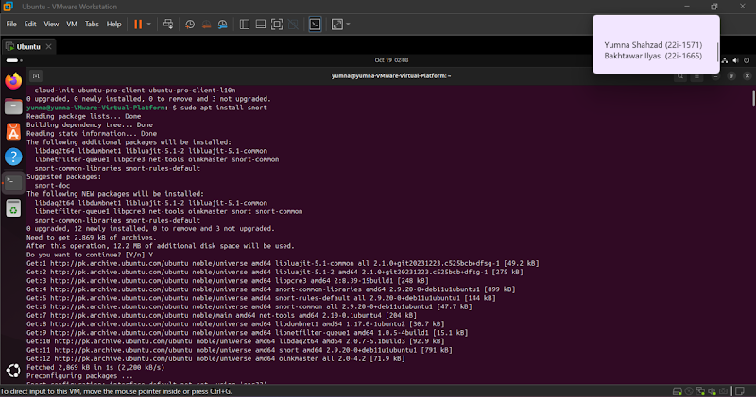

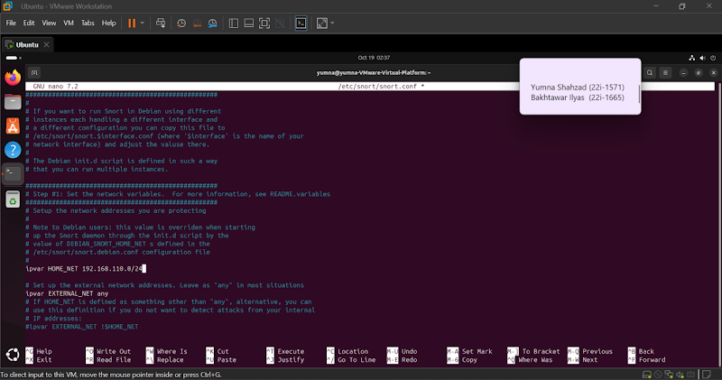

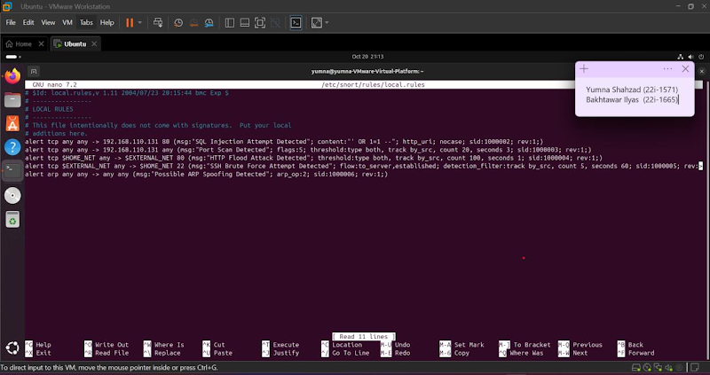

**Attack Detection:**

Next, I simulated a brute-force attack on the server using Hydra, a popular password-cracking tool. Hydra attempted multiple login attempts using a list of potential passwords and a target IP address for FTP. During the brute-force attack, Snort continuously monitored the server's network traffic and logged any unusual patterns, including repeated failed login attempts. Snort detected the brute-force behavior and triggered an alert, notifying the system of the suspicious activity. The logs generated by Snort contained detailed information about the attack, including the source IP addresses and the type of attack (FTP brute-force). These notifications helped confirm that Snort was effectively monitoring the system and provided early warning about the ongoing attack, showcasing the importance of using network intrusion detection systems in enhancing security.

Something worth noting is that when we entered the password wrong three times it logged out, and we had to restart the whole process again.

This process was done using snort.

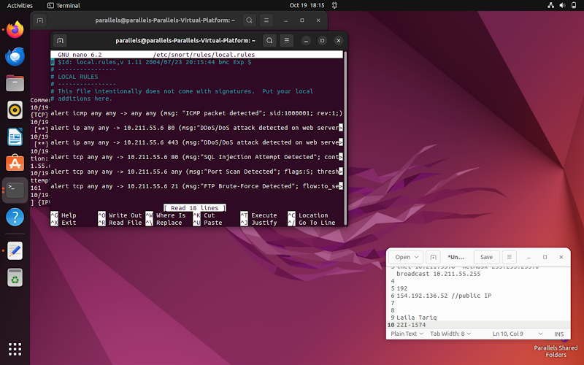

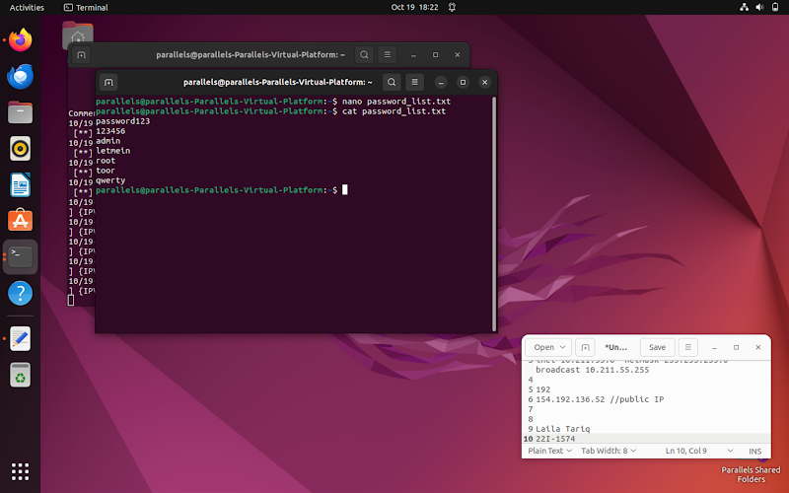

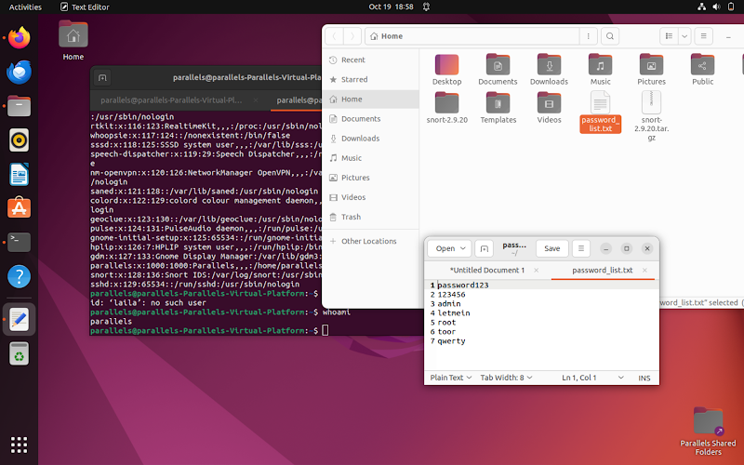

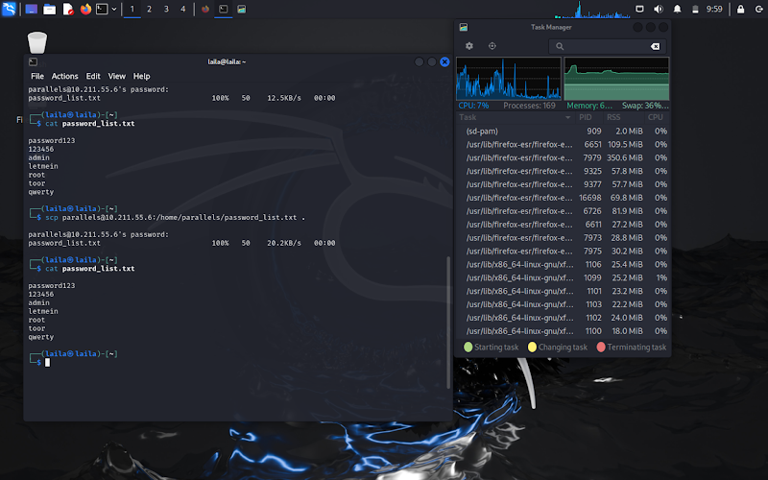

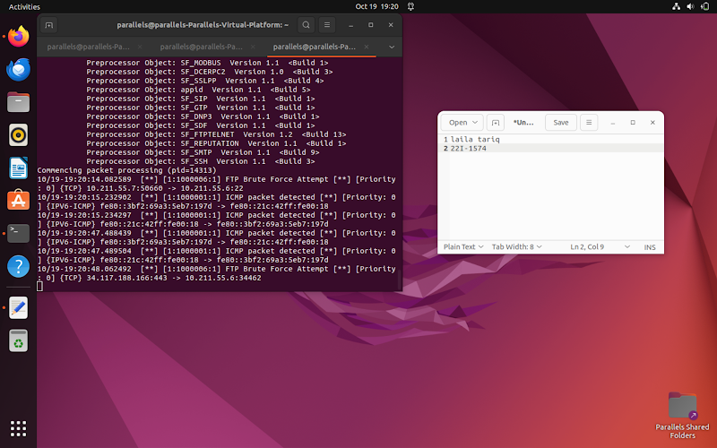

## **3.4:Incidence 3: MXToolBox and Fake Email**

### **3.4.1:Email Spoofing:**

 Fake emails are deceptive messages that often impersonate legitimate sources to trick recipients into revealing sensitive information or performing harmful actions. These emails are commonly used in phishing attacks to harvest personal credentials, spread malware, or defraud users. Fake emails often contain suspicious links, attachments, or requests for sensitive data, and recognizing them requires careful inspection of email headers, URLs, and the message’s tone or context.

The objective of this was to send a fake email using Emkei's Email Generator and then verify its authenticity using MXToolbox. Emkei is an online service that allows users to send spoofed emails, where the sender's name and email address can be fabricated. I used Emkei to send an email with a fake sender, making it appear as though it came from a legitimate domain (e.g., "d marc"). After receiving the email, I used MXToolbox to check the email's domain for various security features that verify its authenticity, including DNS records, blacklist status, and email authentication methods such as SPF, DKIM, and DMARC.

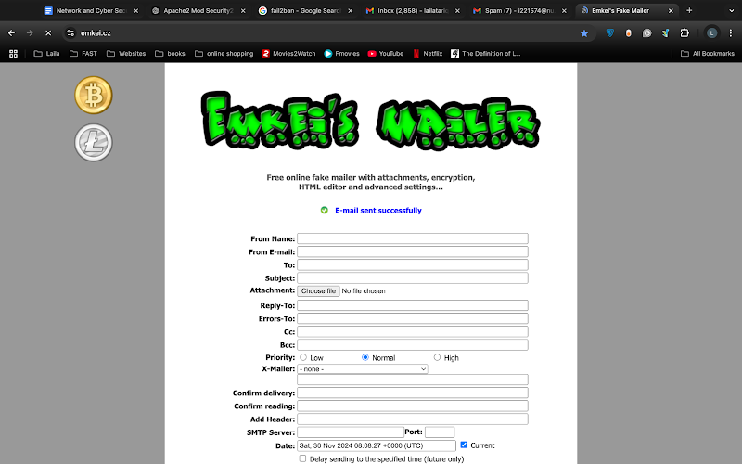

MXToolbox reported that the domain used in the fake email did not have a DMARC (Domain-based Message Authentication, Reporting, and Conformance) record, which is an email security protocol that helps prevent spoofin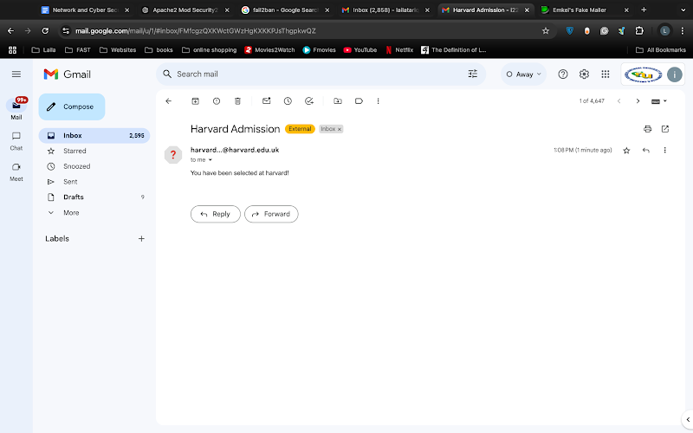g and phishing attacks. DMARC allows domain owners to specify which mail servers are authorized to send emails on behalf of their domain and provides instructions on what to do if an email fails authentication. The absence of a DMARC record is a significant indicator that the email is not legitimate. A legitimate email domain typically has DMARC set up to protect against fraudulent emails, and the absence of this feature makes it highly likely that the email is fake.

In addition to DMARC, other email authentication protocols such as SPF and DKIM are commonly used to verify the sender's authenticity. The lack of these features further suggests that the email was sent from an unauthorized source. The absence of a DMARC record combined with these indicators pointed to the email being a spoofed message, potentially sent for phishing or spamming purposes. This exercise demonstrated the importance of email authentication mechanisms in verifying the legitimacy of email communications, and the absence of DMARC serves as a clear sign that the email was fake.

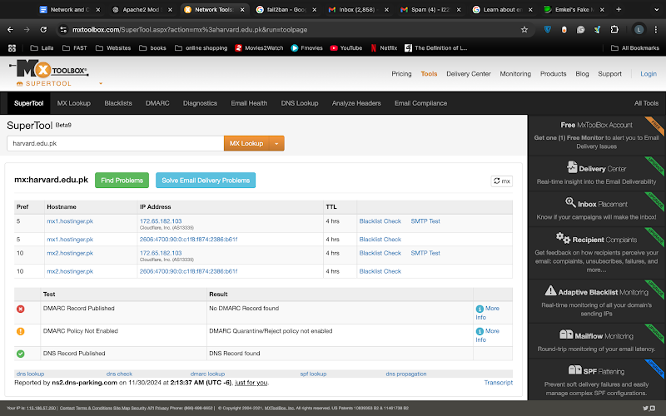

## **3.5 :Incidence 4: Fail2Ban and SSH**

### **3.5.1 SSH Intrusion Attempts**

**SSH: SSH (Secure Shell**) is a cryptographic network protocol used to securely access and manage devices over an unsecured network. It allows users to authenticate to remote systems and execute commands securely using encryption, ensuring confidentiality and integrity of data during transmission. SSH is commonly used for remote server administration and file transfers, offering strong security when properly configured with key-based authentication instead of password-based logins.

As part of securing the Ubuntu system against unauthorized access and brute-force attacks, Fail2Ban was installed and configured. This task aimed to enhance server security by monitoring authentication logs and banning suspicious IP addresses. Initially, the installation process involved updating the system repositories and installing Fail2Ban using the command-line interface. Once installed, the Fail2Ban service was enabled and started, but an issue was encountered where the service failed to run successfully, reporting an error related to accessing the socket path /var/run/fail2ban/fail2ban.sock.

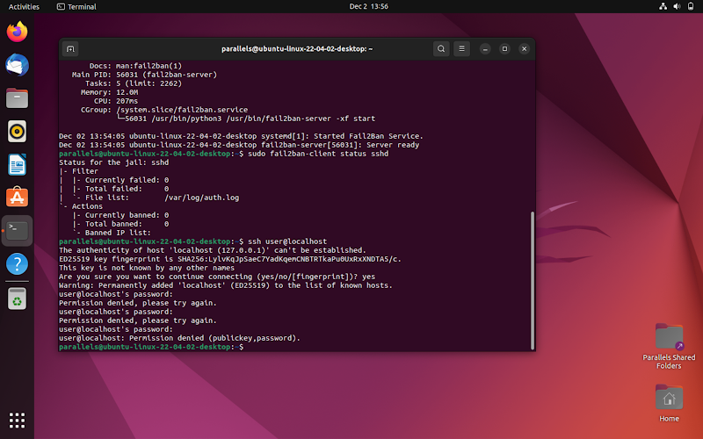

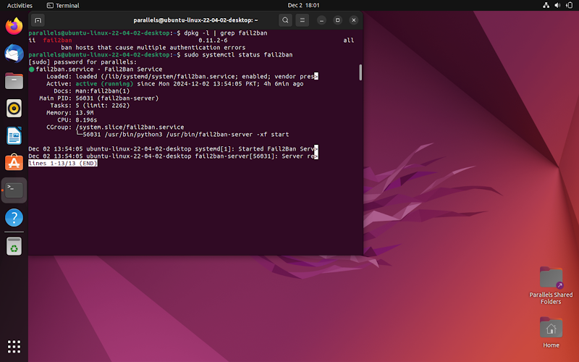

### **3.5.2 Fail2Ban and Log Analysis**:

**To validate the configuration,** Fail2Ban's jail configurations were reviewed and adjusted using /etc/fail2ban/jail.local. The focus was on enabling the SSH jail, which monitors authentication logs in /var/log/auth.log for failed login attempts. This configuration ensures that repeated failed logins from a single IP address trigger a temporary ban. A self-attack simulation was conducted to test the system's responsiveness. Multiple failed SSH login attempts were generated from a specific IP address to simulate a brute-force attack.

**The objective** was to evaluate the effectiveness of Fail2Ban in detecting SSH login attempts were made using incorrect credentials. These failed login attempts were logged in the server's /var/log/auth.log file, where each entry would indicate a failed password attempt, along with the IP address attempting the login. Once Fail2Ban detected a threshold of multiple failed login attempts from the same IP address, it flagged the suspicious activity and initiated a defensive action.

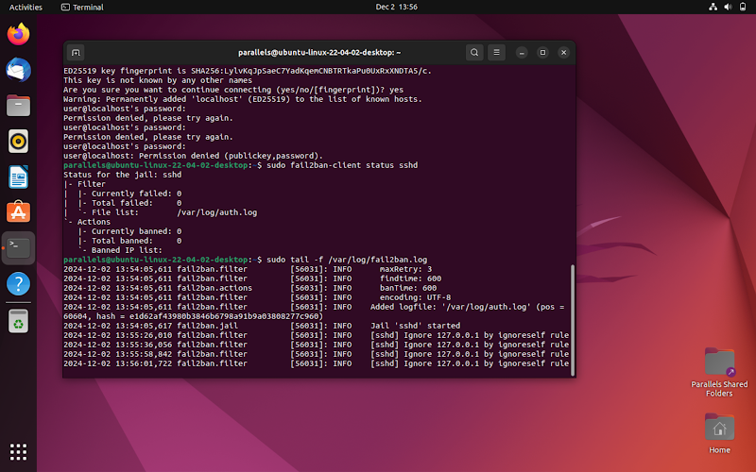

Fail2Ban responded by adding the attacking IP address to its ban list, which effectively blocked further connection attempts from that IP. The system’s automated defenses were validated by reviewing the Fail2Ban logs, which showed the banned IP address and confirmed that Fail2Ban was functioning as intended. Additionally, Fail2Ban "jailed" the attacking IP by configuring the firewall to prevent any further attempts from the identified source. This process was automatically managed by Fail2Ban, requiring no manual intervention. The exercise highlighted the importance of log monitoring in incident response, showing how reviewing system logs helped ensure the proper functioning of the defense mechanisms. It also emphasized how proactive measures, such as configuring and maintaining Fail2Ban, add an extra layer of security, mitigating the risks posed by brute-force attacks while enabling effective incident response workflows.

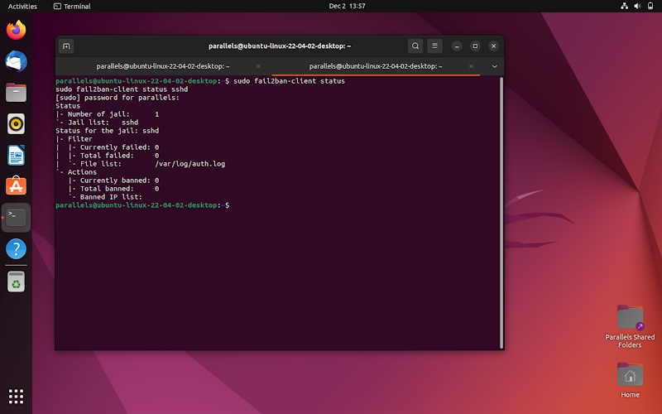

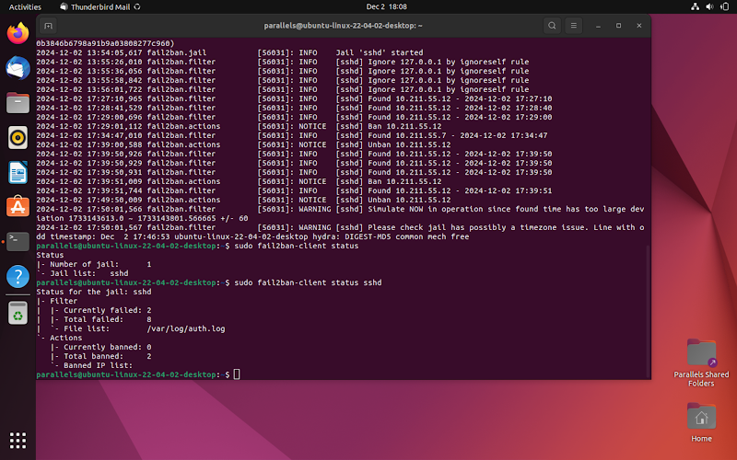

### **Incident 5 (Bonus): Medusa Brute-Force Attack**

**1.Medusa Overview**:

* A powerful parallel network login brute-forcer.
* Supports multiple protocols (e.g., SSH, FTP, HTTP).
* Used for penetration testing to identify weak passwords.
* Runs multiple tasks simultaneously for faster brute-forcing.

**2.Attack Execution**:

* Target: SSH service on a remote system.
* Configuration:
* Specified target IP, username, and a password list.
* Process: Medusa systematically attempted login combinations from the wordlist.

**3.Outcome**:

* Attack failed due to a strong password on the SSH account.
* Password complexity (mix of letters, numbers, special characters) effectively resisted brute-force attempts.

**4.Key Takeaway**:

* Strong passwords significantly reduce the risk of unauthorized access from brute-force attacks.

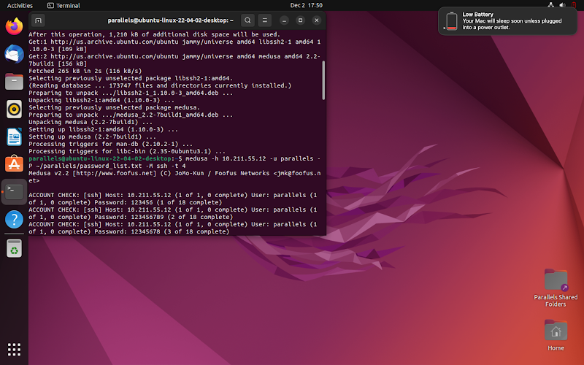

# **5) Challenges and Learnings**

Throughout our work on incident response, we faced challenges in setting up tools like Wazuh across different systems, simulating attacks with Burp Suite and SQLmap, and interpreting real-time results. Configuring Wazuh for accurate threat detection, especially for SQL injection, required customizing rules and understanding log analysis. This process deepened our knowledge of security tools, incident response methodologies, and the importance of iterative, layered security strategies. The experience emphasized the value of proactive monitoring, timely alerts, and comprehensive measures to detect and mitigate vulnerabilities effectively.

# **6) Conclusion**

In conclusion, the work we have done regarding incident response has provided valuable practical experience in understanding how security systems detect, respond to, and mitigate cyber threats. By configuring Wazuh as a central monitoring tool, performing SQL injection attacks using Burp Suite and SQLmap, and observing Wazuh’s response to these attacks, we have gained a comprehensive understanding of both offensive and defensive cybersecurity strategies. The hands-on experience with real-world attack simulations allowed us to explore the intricacies of attack vectors, such as SQL injection, and provided insight into the importance of real-time threat detection and continuous monitoring. Additionally, by engaging with various tools and methodologies, we have learned how to customize and fine-tune security systems to respond to specific threats effectively.

Furthermore, this work highlighted the significance of integrating different security tools and techniques to create a robust incident response framework. The combination of Burp Suite’s manual interception capabilities, SQLmap’s automated exploitation, and Wazuh’s threat detection mechanism demonstrated how an effective incident response strategy requires collaboration between various security technologies. The project also underscored the importance of incident tracking, analysis, and remediation, as these activities are vital to improving the security posture of any organization. The integration of threat intelligence, log analysis, and real-time alerting within Wazuh has proven to be a critical aspect of identifying and mitigating cyber threats.

Ultimately, the experience has equipped us with a deeper understanding of cybersecurity concepts, especially incident response, vulnerability detection, and log management. This knowledge is essential not only for mitigating attacks like SQL injections but also for preparing systems to identify and react to new threats. As cybersecurity challenges evolve, so too must our ability to detect, prevent, and respond to them. This work has reinforced our commitment to developing skills in incident response and staying current with emerging technologies to build stronger defenses against cyber threats.

# **7) References**

Here are the references:

1. **Wazuh Documentation**, "Wazuh: Open Source Security Monitoring," Wazuh,[https://documentation.wazuh.com/](https://www.google.com/url?q=https://www.google.com/url?q=https://documentation.wazuh.com/&amp;sa=D&amp;source=editors&amp;ust=1739034151873947&amp;usg=AOvVaw2XxHJKoUW4vVGt-dMn_rOk&sa=D&source=docs&ust=1739034151941749&usg=AOvVaw2Ly-gjX74IMtew7qvDYzEB).
2. **Burp Suite Documentation**, "Burp Suite: The Leading Web Security Testing Tool," PortSwigger,[https://portswigger.net/burp](https://www.google.com/url?q=https://www.google.com/url?q=https://portswigger.net/burp&amp;sa=D&amp;source=editors&amp;ust=1739034151874224&amp;usg=AOvVaw2jVnXgvveTXzSMVPzyljsv&sa=D&source=docs&ust=1739034151941889&usg=AOvVaw39DigzpbGhbnLYMxZRrL4m).
3. **SQLmap Documentation**, "SQLmap: Automatic SQL Injection and Database Takeover Tool," sqlmap.org,[https://github.com/sqlmapproject/sqlmap](https://www.google.com/url?q=https://www.google.com/url?q=https://github.com/sqlmapproject/sqlmap&amp;sa=D&amp;source=editors&amp;ust=1739034151874451&amp;usg=AOvVaw1PPvL2TrCrTcX5XagG_pSc&sa=D&source=docs&ust=1739034151942048&usg=AOvVaw34HEp0mTDEB_-yN9JhemKw).
4. **OWASP**, "OWASP SQL Injection," Open Web Application Security Project,[https://owasp.org/www-community/attacks/SQL_Injection](https://www.google.com/url?q=https://www.google.com/url?q=https://owasp.org/www-community/attacks/SQL_Injection&amp;sa=D&amp;source=editors&amp;ust=1739034151874701&amp;usg=AOvVaw35dCahS4edS99cZPup3-xU&sa=D&source=docs&ust=1739034151942190&usg=AOvVaw3nZBw3g-g_PTxBiPhvWLCE).
5. **DVWA Documentation**, "Damn Vulnerable Web Application (DVWA),"[https://github.com/ethicalhack3r/DVWA](https://www.google.com/url?q=https://www.google.com/url?q=https://github.com/ethicalhack3r/DVWA&amp;sa=D&amp;source=editors&amp;ust=1739034151874999&amp;usg=AOvVaw2kFgMbJCBFUThs5s6qJQfy&sa=D&source=docs&ust=1739034151942311&usg=AOvVaw3NG9bDRtPuVAfyeFiIVO1q).
6. **Kali Linux Documentation**, "Kali Linux Documentation," Offensive Security,[https://www.kali.org/docs/](https://www.google.com/url?q=https://www.google.com/url?q=https://www.kali.org/docs/&amp;sa=D&amp;source=editors&amp;ust=1739034151875313&amp;usg=AOvVaw1n-DGCTBfisMrIskhu8i-f&sa=D&source=docs&ust=1739034151942429&usg=AOvVaw3hCi_hhLV70QCktoPh49c5).
7. **ModSecurity Documentation**, "ModSecurity: Open Source Web Application Firewall," OWASP,[https://github.com/SpiderLabs/ModSecurity](https://www.google.com/url?q=https://www.google.com/url?q=https://github.com/SpiderLabs/ModSecurity&amp;sa=D&amp;source=editors&amp;ust=1739034151875616&amp;usg=AOvVaw25YeLreGUYRZZu8IJjPCNq&sa=D&source=docs&ust=1739034151942563&usg=AOvVaw1X_DFTW7aXR4rE7ribhXcY).
8. **Snort Documentation**, "Snort: Open Source Network Intrusion Prevention & Detection System," Cisco,[https://www.snort.org/](https://www.google.com/url?q=https://www.google.com/url?q=https://www.snort.org/&amp;sa=D&amp;source=editors&amp;ust=1739034151875900&amp;usg=AOvVaw1OcFnBiPGMPc4-cP8IKvUJ&sa=D&source=docs&ust=1739034151942689&usg=AOvVaw0NuOx2vIJSS_X9ayB8Vd0G).
9. **Hydra Documentation**, "Hydra: A Fast Network Logon Cracker," GitHub,[https://github.com/vanhauser-thc/thc-hydra](https://www.google.com/url?q=https://www.google.com/url?q=https://github.com/vanhauser-thc/thc-hydra&amp;sa=D&amp;source=editors&amp;ust=1739034151876269&amp;usg=AOvVaw3D6CYD6psu4lG2C3vcgRqV&sa=D&source=docs&ust=1739034151942827&usg=AOvVaw2rtqzlayUFIqRYTRL16VGg).
10. **MXToolBox**, "MXToolBox: DNS and Mail Server Diagnostics," MXToolBox,[https://mxtoolbox.com/](https://www.google.com/url?q=https://www.google.com/url?q=https://mxtoolbox.com/&amp;sa=D&amp;source=editors&amp;ust=1739034151876607&amp;usg=AOvVaw024wOkBAUf16yL33hq3IrP&sa=D&source=docs&ust=1739034151942973&usg=AOvVaw3oIobHipqsO648-w_27-4K).
11. **Fail2Ban Documentation**, "Fail2Ban: Protecting Servers Against Brute Force Attacks," Fail2Ban,[https://www.fail2ban.org/](https://www.google.com/url?q=https://www.google.com/url?q=https://www.fail2ban.org/&amp;sa=D&amp;source=editors&amp;ust=1739034151876910&amp;usg=AOvVaw3Ytu7LO7LMVEJR3a9BKrVQ&sa=D&source=docs&ust=1739034151943094&usg=AOvVaw20oquV29d1N-MrzaO0DSwH).